How to Use WikiSpaces.
Open http://www.wikispaces.com/site/for/teachers
Complete the details on the Join Now Form.
See below for example:
1. Username
2. Password
3. Email Address | We will not spam or share your email address.
4. Make a Wiki? | Yes No  Create a wiki now or after you join.
5. Wiki Name | Choose a name between 3 and 32 characters long Use – instead of spaces
6. Wiki Permissions | Public (free)  Everyone can view and edit your pages.  Protected (free)  Everyone can view pages, only wiki members can edit them.  Private (free for educators otherwise $5/month)  Only wiki members can view and edit pages.
7. Educational Use | I certify this wiki will be used for K-12 education.  We may contact you via email to verify use.
Terms of Use

Once you have registerd for Wikispace you can add more spaces if you need later by logging in with your account details

Your Wiki Page will open. 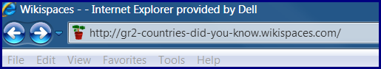
Copy the Address from the address bar and paste into a word document. Record you username and password on this document. Your students will be able to use this document to access the Wiki.
Once they open the page they will be prompted for a username and password
Username
Password
Click on the edit page link to edit this page or to add information to it.
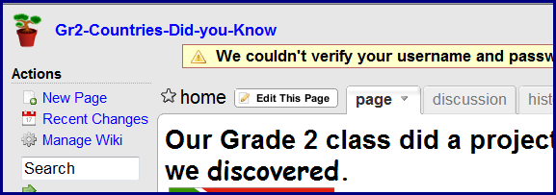
Learners can type and format their text on a word document and copy and paste onto this page.
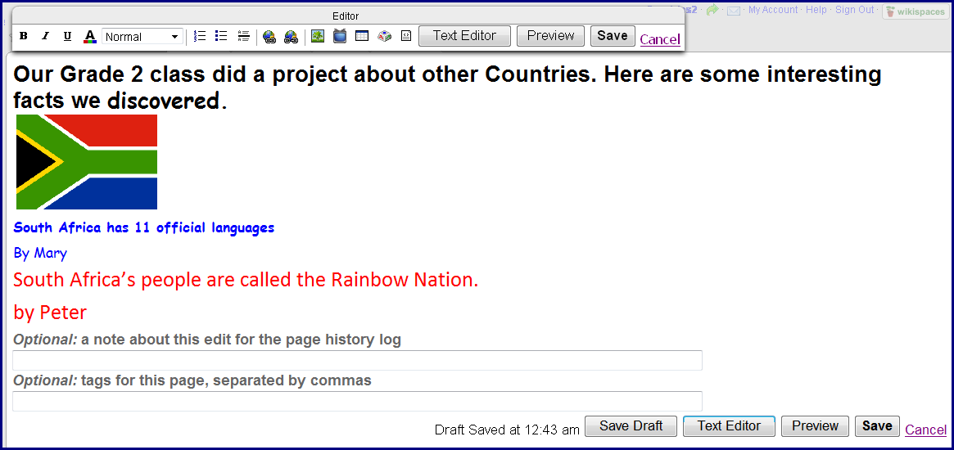
Pictures can be uploaded to this page from the learners’ computers. To Upload a picture click on the Insert image icon on the toolbar
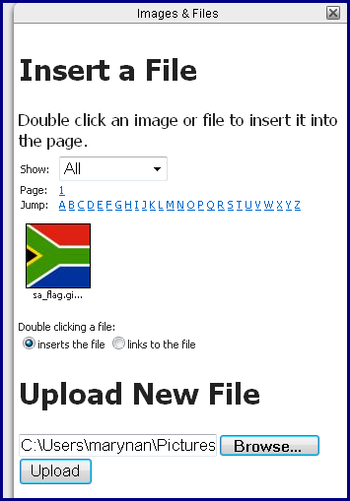
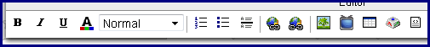

Click on browse to find the picture and click on upload

